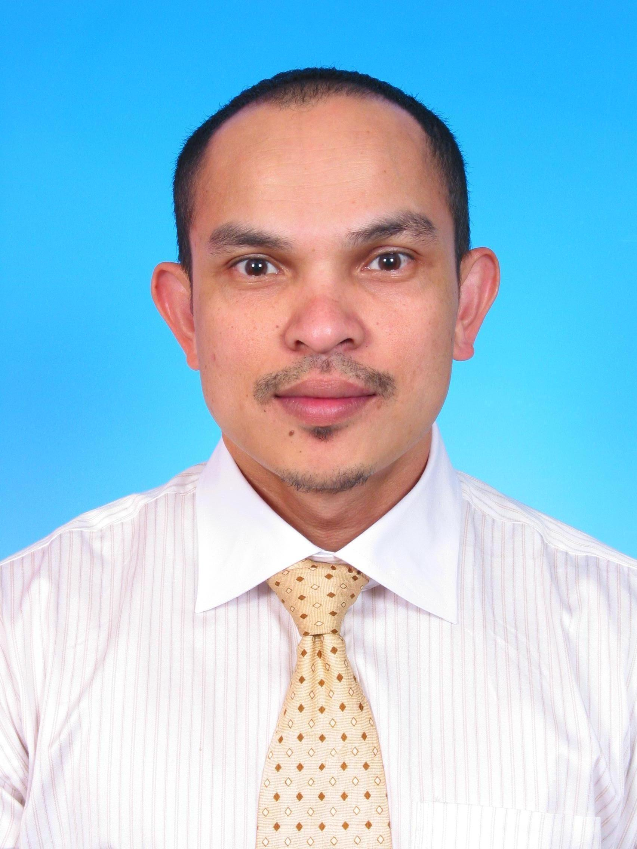

No D-9-6

Cityview Condominium

2 ½ Miles Jalan Cheras

51200 Kuala Lumpur

+6017-3273420

arahn3370@gmail.com

# OBJECTIVE

Career advancement in senior management position

**KNOWLEDGE AND SKILLS**

Member of Malaysia Institute of Accountant

Member of Certified Public Accountant Australia

More than fifteen years of experience in finance, administration and human resource including four years in internal audit.

Good working knowledge in accounting standards (FRS), consolidation, tax legislation and regulatory financial reporting requirement.

Implementation of ISO9000 and new system for inventory department

Well versed with ACCPAC, SAP, IFCA, MYOB, Peach Tree, UBS, Microsoft Office

Solid project accounting experience including budgeting, forecasting, costing, billing, good and service tax (GST) , preparation of financial statements and cash flow management.

Solid Human Resource experience including payroll, training and welfare of the staff.

Interact very well with all levels across the organization, and portfolio include statutory reporting, tax, financial planning and analysis, working capital management, business plan, internal controls review, process improvement as well as ad hoc projects.

Solid experience in public relations and managing events.

Excellent leadership, organizational and people management skill

Excellent command of verbal and written communication in English and Bahasa Malaysia

Committee member of finance for annual dinner and family day

Possess a Valid United Arab Emirates Driving License

Willing to be based at any states in Malaysia and any countries around the world

# WORKING EXPERIENCE

**Aug 2013 – July 2017 Senior Accountant /Finance Manager**

**MUHIBBAH ENGINEERING (M) BERHAD**

**Nature of Business: Construction, Engineering, Oil & Gas**

**Remarks: Reason for wanted to leave: Contract Basis - Looking for better career prospect**

* Lead the Finance team and manage all aspects of the Company’s Finance matters in compliance with the Company’s policies and procedures Maintain the Company’s financial records Perform the preparation, review and analysis of the management’s monthly reports and annual budgets
* Acting as Period-end Closing Coordinator: Ensure that month end closing processes are adhered to by all responsible persons in accordance with agreed closing schedule. Work closely with users to obtain timely and accurate accrual input. Perform tasks relevant to closing such as cost allocation, cutback and settlement
* Responsible in preparing cash flow statement on a monthly basis and reporting on variance to budget and forecast future trends. Forecasting cash inflow and outflow in order to meet the tight available balance.
* Responsible for preparation of Statutory Financial Statements (for financial year 2014 and 2015) and ensure that the Financial Statements are prepared in accordance with Applicable Accounting Standards. Working with KPMG, the external auditors to have the Accounts audited and submitted timely to Companies Commission of Malaysia (CCM).
* Support the system in ensuring all assets, liabilities, expenses and revenues are captured in accordance with IFRS/MFRS. Prepare monthly fixed asset reporting such as fixed asset roll forward, reconciliation for fixed asset accrual account, CIP aging report. Update month end close package analysis.
* Prepare Year-end Financial Inputs and Relevant Accounting Schedules for consolidation at Head Office Level. Working with user department to compile input and reconcile movement of provision to last year provision and provide explanations.
* To continuously asses the ORACLE accounting system for potential improvement. This is critical to continuously meet and support reporting requirements by various parties such as partners, Petronas.
* Formulate and review accounting processes/policies throughout the company to ensure accounting and financial reports accurately reflect the conditions of the business and provide reliable information for control and management purposes
* Act as JV Audit Coordinator (PETRONAS/PCSB/KPMG): Working with relevant users to ensure that documents required for audit are prepared and compiled in advance. Coordinate and follow up audit queries by auditors and follow up and resolve outstanding audit issues/findings
* Liaise with Operations Team on project status to ensure revenue recognition in accordance with approved accounting standards
* Responsible for timely GST submission and to ensure payments are made to the relevant authorities
* Liaise with auditors, tax agents, company secretary, insurance, banks and other statutory bodies/ authorities on internal and external audit matters, and all statutory and tax requirements compliance.
* Assist in preparing ad-­hoc accounting projects as assigned by the management and perform other relevant ad-­hoc or administrative tasks assigned by the management as required

**Jan 2010– May 2013 Finance and Administration Manager**

**HSSI-SNC LAVALIN Joint Venture**

**Nature of Business: Consultant for MRT Corporation for LRT & MRT Project from Sungai Buloh to Kajang.**

**Last Drawn Salary: RM8,000-00**

**Reason for Leaving: Contract Completed**

* Reporting to the Project Director and Commercial Director of the project. I was responsible for the entire company’s daily operation, preparing full set of accounts, including budgeting, forecasting, costing, billing and timely financial and management reporting.
* To assist the management on all strategic and tactical matters relating to budget management, cost benefit analysis, forecasting needs and the securing of new funding.
* Monitor the overall finance performance, control of accounting function of the company, especially the area of development and accounting information system. To update and advise the top management of any discrepancies.
* Interact very well with all levels across the organization, and portfolio include statutory reporting, tax, costing, financial planning and analysis, working capital management, business plan, internal controls review, process and improvement.
* To manage and structure the company’s financial and management reporting systems and streamline processes to provide management with relevant and timely financial information. To provide strategic and financial advice for the business.
* To manage company funds investment to achieve the target annual return.
* To work closely with respective business unit head on the preparation of overall financial management, forecasts and budget analysis.
* Monitor staff performance and administration of Finance Department.
* **To manage all financial activities in compliance with accounting standards, statutory filing requirements; and reporting in line with company’s standards and emphasis on timely reporting and accountability.**
* Formulate and review accounting processes/policies throughout the company to ensure accounting and financial reports accurately reflect the conditions of the business and provide reliable information for control and management purposes.
* Overseas day-to-day Human Resource activities including developing the appropriate HR strategic plan including recruitment, succession planning, key performance indicators (KPI), employment policies and compliance.
* Oversee and manage all matters pertaining to day-to-day administration matters including office maintenance, purchasing and vehicles management.
* Oversee GST compliance and submission to custom
* Liaise with auditors, tax agents and related statutory bodies to ensure the compliance to all matters relating to audit, taxation and GST.

**Oct 2005 – Dec 2009 Project Accountant**

**Rekayasa Industri Malaysia Sdn. Bhd.**

**Nature of Business: Oil & Gas - Engineering & Construction of Miri Crude Oil**

**Terminal (MCOT), PETRONAS, Miri, Sarawak**

**Joint venture project between Syarikat Permodalan Kebangsaan (SPK) and PT Rekayasa Industries Indonesia, Jakarta, Indonesia**

**Reason for Leaving: Project Completed**

* Reporting to the Project Director and Financial Controller. I was responsible for the entire company’s full set of accounts, including budgeting, forecasting, costing, billing, tax planning and timely financial and management reporting.
* Handle an important role in providing business decision support to Project Director as well as providing leadership and direction to the finance team.
* Participate in negotiation activities, developing proposals, financial module, corporate fund raising, budgeting and provide quality review of valuation analysis.
* Interact very well with all levels across the organization, and portfolio include statutory reporting, tax, costing, financial planning and analysis, working capital management, business plan, internal controls review, process improvement as well as ad hoc projects.
* Ensure the effectiveness of working capital management in particularly, debts collection and credit management.
* Responsible to coordinate all planning cycles including rolling forecast and annual operating plan for the operating entities.
* Oversee day-to-day financial activities of the accounts department including cost accounting, stock valuation, Cost of Sales (COS) calculation, accounts payable, accounts receivable and credit control.
* Overseas day-to-day Human Resource activities including developing the appropriate HR strategic plan including recruitment, succession planning, key performance indicators (KPI), employment policies and compliance.
* Oversee and manage all matters pertaining to day-to-day administration matters including office maintenance, purchasing and vehicles management.
* Implement and approve financial, human resource and administration policies and procedures in accordance to the business needs and along with the guidelines of corporate policies.
* Direct and manage all tax related affairs of the company as well as liaising with customs, auditors and other third party professionals.
* Ensure compliance of local regulations in relation to Financial Reporting Standards (FRS), Company Law, Labour Law and other regulations in relation to the business.
* Responsible in handling banking facility such as bank guarantee and letter of credit.
* Liaise with external auditors, tax consultants, bankers, notaries and lawyers

**1. Jan, 1995 – Sept 2005 Senior Accounts Executive**

**Alpine Offshore Sdn. Bhd.**

**Nature of Business: Oil & Gas Industry**

**Offshore**  
Offshore the coast of Kerteh, Terengganu, Alpine Exploration and Production Malaysia Inc. operates more than ten platforms.

**Kemaman Supply Base**  
Alpine Exploration and Production Malaysia one of the tenants of the Kemaman Supply Base which provides logistical support services such as ware-housing, maritime transportation and berthing facilities.

Reason for Leaving: Better Career Prospects

**Accounts Function:**

* Reporting to the Financial Controller of both joint venture partners. I was responsible for the entire company’s full set of accounts, including budgeting, forecasting, costing, billing, and tax planning and timely financial and management reporting.
* Preparing monthly forecast of the Profit and Loss Accounts for the Operations Controller.
* Act as JV Audit Coordinator (PETRONAS/PCSB/KPMG): Working with relevant users to ensure that documents required for audit are prepared and compiled in advance. Coordinate and follow up audit queries by auditors and follow up and resolve outstanding audit issues/findings
* Responsible for the liaison with PSC JV partners for all aspects of the AFE administration in particular twill ensure that approval is obtained in a timely fashion.

**2. 1989 –Dec 1994** **Internal Audit Officer**

**Tractors Malaysia (1982) Sdn. Bhd.**

**Nature 0f Business: Diversified Business – Cars & Heavy Vehicles & Equipment**

**Accounts Function:**

* Started as a Treasury Clerk, responsible for all the treasury transactions in Account Payable including preparing payment for overseas suppliers (Auto Bavaria and Land Rovers)
* Responsible in recording REPO/FD placement in ERP accounting system
* Review and evaluate the adequacy and effectiveness of the management’s control over operations and financial control.
* Deliver value-added recommendation and ensure completion of assignments in conformance with planned budget and schedules.
* Assist in planning and execute audits in accordance with accepted standards in professional manner.
* Assist in evaluation and preparing audit report to be submitted to the Audit Committee.
* Reason for Leaving: Better Career Prospects

# EDUCATION

2002 Malaysian Institute of Accountant

Membership No. : 20514

1. Certified Public Accountant Australia

Membership No. : 9257281

April 2002 Universiti Teknologi Mara Shah Alam

Degree In Accountancy – CGPA 3.36

1992 –1995 Universiti Teknologi Mara Shah Alam

Diploma In Accountancy – CGPA 3.17

1982 –1987 Sekolah Tengku Ampuan Jemaah Klang

SPM – Grade 2

SRP – Grade A

# PERSONAL DATA

Date of Birth 03 March 1970

Sex Male

Height 169 cm

Weight 70 kg

Health Good

Citizenship Malaysia

Marital Status Single

Language Bahasa Malaysia & English

# INTEREST

Swimming, gym, football, bowling, reading, traveling, music, theatre, social work

# OTHERS

Expected Salary: Within the range of RM9, 000.00 to RM10, 000.00

End.